Section 3.2 — Maternal Age by Birth Order

Figure 2: Maternal Age by Birth Order
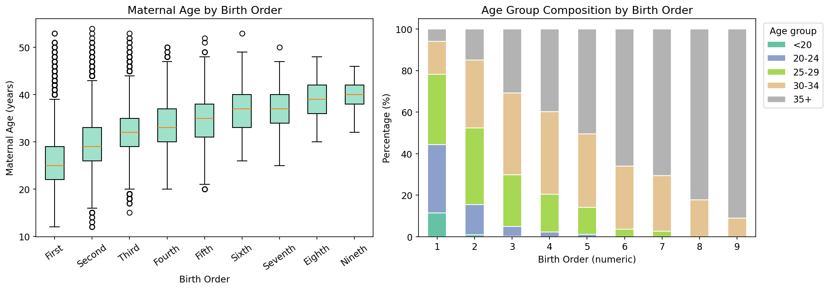

Table 1: Maternal Age Descriptive Statistics by Birth Order
Birth Order | Parity | N | Mean | Median | Std Dev | Min | Max | Q1 | Q3
First | 1 | 141,381 | 25.69 | 25.00 | 5.23 | 12 | 53 | 22.00 | 29.00
Second | 2 | 108,642 | 29.44 | 29.00 | 4.83 | 12 | 54 | 26.00 | 33.00
Third | 3 | 49,739 | 32.11 | 32.00 | 4.75 | 15 | 53 | 29.00 | 35.00
Fourth | 4 | 12,941 | 33.42 | 33.00 | 4.72 | 20 | 50 | 30.00 | 37.00
Fifth | 5 | 4,007 | 34.63 | 35.00 | 4.67 | 20 | 52 | 31.00 | 38.00
Sixth | 6 | 1,040 | 36.55 | 37.00 | 4.28 | 26 | 53 | 33.00 | 40.00
Seventh | 7 | 381 | 36.92 | 37.00 | 4.14 | 25 | 50 | 34.00 | 40.00
Eighth | 8 | 124 | 38.72 | 39.00 | 4.20 | 30 | 48 | 36.00 | 42.00
Nineth | 9 | 33 | 39.76 | 40.00 | 3.41 | 32 | 46 | 38.00 | 42.00

Note: N = number of births. Q1/Q3 = 25th/75th percentile of maternal age.

Table 2: Age Group Composition (%) by Birth Order
Birth Order | <20 | 20-24 | 25-29 | 30-34 | 35+
First | 11.51 | 32.81 | 33.88 | 15.80 | 5.99
Second | 0.98 | 14.60 | 36.76 | 32.72 | 14.94
Third | 0.22 | 4.83 | 24.86 | 39.26 | 30.83
Fourth | 0.00 | 2.36 | 18.19 | 39.61 | 39.83
Fifth | 0.00 | 1.17 | 12.90 | 35.44 | 50.49
Sixth | 0.00 | 0.00 | 3.65 | 30.38 | 65.96
Seventh | 0.00 | 0.00 | 2.62 | 26.77 | 70.60
Eighth | 0.00 | 0.00 | 0.00 | 17.74 | 82.26
Nineth | 0.00 | 0.00 | 0.00 | 9.09 | 90.91

Note: Values represent the percentage of mothers in each age group within each birth order category.

